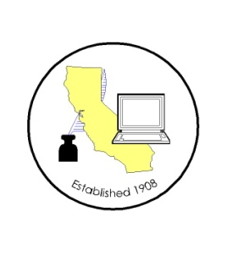
CALIFORNIA ASSOCIATION OF

CLERKS AND ELECTION OFFICIALS

April 13, 2012

TO: CACEO Members, Guests, Legislative Committee

FROM: Deborah Seiler and Jill LaVine, Co-Chairs

SUBJECT: CACEO LEGISLATIVE COMMITTEE MEETING

DATE: FRIDAY, April 20, 2012

TIME: 9:00 a.m. – 3:00 p.m.

LOCATION: County of Sacramento
799 G Street, OCIT – 2nd Floor Conference Room
Sacramento, CA 95814

Subcommittee Meetings, Thursday, April 19, 2012

1 pm – 3 pm Voters with Specific Needs – Tim McNamara

3 pm – 5 pm HAVA/Certification/Voting Systems – Tim McNamara

FRIDAY AGENDA

9:00 am Welcome and Introductions

Approval of March 23, 2012 meeting minutes

“Maintaining Voter Files/List Maintenance” -- Neal Kelley

USPS Issues – Jill LaVine and Cathy Darling Allen

Discussion of Bills
AB 1724 Fong, am. 3/29
AB 1805 Huffman, am. 4/10
AB 1814 Eng
AB 1851 Allen, am. 4/10
AB 1929 Cook
AB 1979 Roger Hernandez, am. 4/10
AB 2080 Gordon
AB 2191 Norby
AB 2299 Feuer
AB 2452 Ammiano
AB 2479 Donnelly
SB 1083 La Malfa
SB 1188 Senate Elections, am. 4/9
SB 1233 (Padilla), am. 3/27
SB 1272 Kehoe
SB 1275 Lieu
SB 1346 Negrete McLeod, am. 4/12

Subcommittee Reports

Adjourn

